Proposed solutions

[make it clear that the solutions are to the isotope mass balance and ideally, resolution to the mass imbalance will sprout from that]

1. Brandi (particulate load of rivers)
   1. Thought that the particulate load of rivers could be a heavy source of Ni to the oceans
   2. For the amazon at least, even if the entire particulate load was mobilized and reactive in the oceans, it would provide isotopically light Ni and worsen the isotope imbalance
   3. Other rivers supply Ni (and potentially a large component according to Laura) so this might be an interesting avenue, but not very promising if Fe oxides are the main transport mechanism (sorb light Ni)
2. Hydrothermal input?
   1. Possible, not much isotope data related to it, but size likely not influential enough unless it is wildly fractionated.
   2. Hot on ridge systems not a significant source (look into ciscato explanation)
   3. Cooler/ higher flux systems also likely not a source (Wheat papers)
   4. Unless isotopes are wild, this source is likely not super important
3. Alvarez (carbonate sink)
   1. Lesser studied sink, abundance of carbonates make it an interesting potential solution of a light sink
   2. Can mention experimental data from Alvarez (and short comings)
   3. Mention sinking biogenic particles from Takano sinking particle paper (light Ni associated with particles)
      1. However, we know Ni is incorporated in diatoms (in the frustule and the internal biology) so maybe not representative of carbonates
   4. Ciscato, measurements of carbonate rich samples
      1. Carbonate rich, but from organic material, not much exploration of diagenetic effects or mineralogy
   5. Could be important for the isotope balance, and impact of diagenesis has not been assessed
      1. Could also potentially learn how diagenesis affects the primary signature of dNi in carbonates and assess it’s utility as a record of dNi.
4. Vance (benthic flux from Fe-Mn) crust
   1. Idea that Mn oxides deposit as ~1.6 and then redox cycling (Or todorkite) leads to a flux of heavy Ni back to the column.
   2. If redox cycling of Manganese oxides is a benthic flux back, we’d expect light Ni isotopes released where Mn reduction occurs in the huge Gueguen 2021 column, but we don’t (barely any change even though large change in Mn
   3. Cannot explain Vance 2016 data from the Black Sea
   4. We pick alternative hypothesis: Mn oxides aren’t equal and therefore don’t fractionate Ni equally.

Heavy sources?

**Hydrothermal paragraph**

Hydrothermal activity has been suggested as a possible Ni source, but no data yet suggests that hydrothermal activity is of the appropriate magnitude or isotopic composition to account for the isotope imbalance. The hydrothermal input of Ni appears to be negligible compared to other sources (i.e., rivers), and therefore the related isotope fractionation would have to be extreme for the hydrothermal flux to resolve the isotope imbalance. There is no observed increase in [Ni] across the Mid-Atlantic Ridge from the GEOTRACES transect GP16 (Fig XXX) (cite ciscato or geotraces?), suggesting high temperature hydrothermal systems are not a significant input of Ni. Low temperature ridge flank systems, which have much larger fluxes of water, also do not appear to be a source of Ni. (Wheat et al., 2003, 2002) conducted two studies exploring ~65℃ and 25℃ ridge flank systems and found a very small source (1.5% of the riverine flux, correct for modern estimate of river flux) or a very small sink (-1.8% of the riverine flux, corrected for modern estimate of river flux), respectively. However, ridge flanks of these temperatures (≥25℃) account for only 25% of the total convective heat loss from ridge flank type hydrothermal systems (and 17% of the total oceanic convective heat loss). The remaining 75% of the convective heat loss, and a significant portion of the fluid flux, comes from cooler ridge flank systems (≤25℃) which may have different [Ni] and could either be a source or sink of Ni (Wheat et al., 2003).

If the hydrothermal flux was of the appropriate size, would it be the appropriate isotopic composition to balance the equation?

**Riverine Particulate Load Paragraph**

The suspended particulate load (SPL) of rivers has been suggested as potential resolution to the mass and isotope imbalance, but there are two problems (1) the debated size this flux and (2) the generally isotopically light composition of the known components. The SPL consists of a variety of particles (*e.g.,* clays, carbonates, Fe and Mn oxyhydroxides, organic complexes) which can contain a significant fraction of the total riverine load for a given metal (Gaillardet et al., 2003; Gibbs, 1973). A handful of studies have calculated the SPL Ni/dissolved Ni in a variety of rivers and determined a wide range of values (0.4x to 40x), with a large portion hosted by Fe and Mn oxyhydroxide phases (Gibbs, 1977, 1973; Revels et al., 2021; Seyler and Boaventura, 2003; Viers et al., 2009). Depending on the study, either only a very small portion or the entirety (including the silicate fraction) of the SPL would have to be mobilized to resolve the mass imbalance. [maybe add a sentence about the uncertainty of SPL lability and estuary processes?]

While this source pushes us in the right mass direction, what does this mean for the isotope mass balance? A recent study explored the Ni isotopic composition in a variety of SPL particles of the Amazon river and its major tributaries and found that all of SPL phases (i.e., carbonates, oxides, organic, and residual) were isotopically lighter than solution (all <0.35‰ compared to ~0.9‰ of rivers) (Revels et al., 2021) (Fig xxx). Therefore, even if the entire particulate load were mobilized and reactive in the oceans, it would provide isotopically light Ni and worsen the isotope imbalance. However, this study focused exclusively on Amazon and its major tributaries. Further studies of other major rivers, estuaries and continental shelves could reveal that the particulate load is an important Ni source; although, it appears unlikely that the source would be anything but isotopically light relative to solution based on the trends observed by Revels et al. 2021 and the isotopic fractionation of Fe oxides (Gueguen et al., 2018; Wasylenki et al., 2015).

* [probably useless portions] (Viers et al., 2009) compiled global riverine data and calculated that the SPL Ni flux was almost 40x the dissolved flux (although there SPL flux has a sd equal to its size). (Gibbs, 1977) estimated that ca. 70% of the total Ni riverine load from the Amazon and Yukon Rivers is hosted by Fe-Mn oxide particulates, with less than 10% in the dissolved phase. Considering the particulate load was not considered in the previous mass balance calculations Although these estimates of SPL/dissolved are an order of magnitude different, even in

**Light sinks**

**Carbonate Sink**

Carbonate’s ubiquity in marine settings makes it an attractive candidate as the missing light sink but greatly variable estimates of the flux size and isotopic composition (and the unknown impact of diagenesis) make it difficult to infer their importance to the budget. Nickel partition coefficients for calcite precipitated either abiotically or biotically (via shallow water benthic foraminifer *Ammonia tepida*) are approximately 1 with a very weak negative relationship with precipitation rate (Lakshtanov and Stipp, 2007; Munsel et al., 2010). Concerning the size of the sink, while (Ciscato et al., 2018) estimates carbonates only account for 1.4 x 107 mol Ni/yr (an order of magnitude smaller than rivers) based on Ni/TOC value of carbonate rich sediments from Lagoa Salgada and the total global carbonate carbon burial flux in deep sea sediments, Alvarez et al. 2021 estimates carbonates account of 1.5 to 6.7 x 108 mol Ni/year based on [Ni] data in carbonates from (Zhao and Zheng 2014) and the carbonate carbon burial flux from deltaic, continental shelf and deep sea sediments.

Previous studies have attempted to estimate δ60/58Ni for the carbonate Ni sink, but these estimates might only be partially applicable to marine carbonate precipitation. Ciscato et al., 2018 estimated a carbonate δ60/58Ni range of 1.10–1.64‰. However, they based their estimate on a small sample set (n<8) of carbonate rich (34-75%), organic sediments, rather than pure carbonate samples, without diagenetic histories. [Brandi Revels carbonate data?]. Alvarez 2020 and 2021 have tackled carbonates experimentally (although not equilibrium probably) and found isotopically light Ni sorbs and coprecipitates with carbonates (give estimates of values). [mention short comings of these experiments]. None of these studies have explored the effect of diagenesis which could be another source/sink of Ni (and indicate carbonate’s usefulness as a record of Ni isotopic comp). Considering this may be a significant sink of Ni, getting better estimates of the Ni isotope fractionation of carbonates will be an important step towards resolving the imbalance (at least narrowing down the possibilities).

**Light sink/Heavy source?**

**Mn oxides**

Several studies aimed to determine δ60/58Ni for Mn-rich sediments, perhaps largest sink of Ni, but the results so far are extremely puzzling. Nickel is enriched in Fe-Mn deposits relative to seawater (ca. 106 Ni mol/g Fe-Mn deposits/ Ni mol/g seawater) (e.g., Li and Schoonmaker, 2003) and primarily associated with Mn phases, rather than Fe (e.g., Peacock and Sherman, 2007). The δ60/58Ni of Mn-rich deposits span the entire known natural range of Ni isotopic compositions (ca. -1.8 to 2.5‰) and, inexplicably, appear to be sometimes isotopically heavier and sometimes isotopically lighter than the solution from which they precipitate (Gall et al., 2013; Gueguen et al., 2020, 2016; Gueguen and Rouxel, 2021; Little et al., 2020; Vance et al., 2016). For instance, given the homogeneity of the deep ocean (~1.4 ‰), hydrogenetic ferromanganese crusts have a surprisingly variable isotopic range from 0.25 to 2.47‰, with an average of 1.70 ± 0.63‰ (Gall et al., 2013; Gueguen et al., 2020, 2016). This generally suggests Mn oxides incorporate isotopically heavy Ni relative to solution. [should I add a mention of hydrothermal crusts here?] In stark contrast, the dissolution of Mn oxides in the water column of the Black Sea corresponds to a decrease in δ60/58Nisolution, suggesting isotopically light Ni is associated with Mn oxides (calculated Δ60/58Nisolution-solid ~ 4.0‰) (Vance et al., 2016). More recent studies of hydrothermal Fe-Mn deposits and Mn rich pelagic clays have found a similarly wide range of values, -0.85 ± 0.67‰ (excluding 2 anomalously high values) and 0.07 ± 0.75 ‰, respectively (Gueguen et al., 2020; Gueguen and Rouxel, 2021; Little et al., 2020). Without better knowledge of the main marine Ni sink, correctly modeling the marine Ni cycle is likely impossible.

There are two explanations for the observed 60/58Ni variation in Mn-rich sediments: (1) the initial δ60/58Ni could be roughly the same across sediments, but diagenesis (Mn redox cycling and/or transformation to todorokite) perhaps redistributes Ni isotopes and (2) natural variations could be a consequence of variable initial δ60/58Ni. The first explanation has an added “conceptual” benefit in that this process could provide an input of Ni to the ocean and address the mass balance issue. Suboxic diagenesis of Mn oxides appears to release Ni into porewater, however, corresponding isotope data does not conclusively suggest this Ni is isotopically heavy relative to solid or has any isotope effect at all (Fig XX) (Gueguen and Rouxel, 2021; Little et al., 2020)[insert sentences about (1) the isotope data does not seem to necessarily agree with this, although the conc data might]. Experimental transformation from birnessite to todorokite showed a 50% release of the Ni originally associated with birnessite (~1 wt%), and natural data roughly corroborates this trend (Atkins et al., 2016). However, the rate and extent of this transformation is largely unknown, as well as the Ni isotopic fractionation it may impart. Thus far, only three todorokite rich nodules have been measured for Ni isotopic composition (δ60/58Ni~ -0.22 to 0.01); they tentatively appear to be isotopically lighter than measured phyllomanganate rich nodules (0.28 to 1.06, n =3) and suggest isotopically heavy Ni may be released, although further investigation is clearly warranted. [Does not explain difference between hydrogenetic Fe-Mn crust and black sea sediments]

If the natural variations is due to variable initial δ60/58Ni, what mechanisms might control the variation? Based on natural and experimental observations, there are two readily apparent working hypotheses. First, the variation could be due to differences in Ni coordination environment. Nickel can be structurally incorporated into Mn vacancy sites in birnessite, the dominant Mn phase in natural marine Fe-Mn precipitates (Peacock, 2009), or sorbed on {001} surface sites (triple corner sharing) or edge sites (double corner sharing) (Simanova et al., 2015). A Ni-birnessite sorption study indicated Δ60/58Nisolution-birnessite positively correlates with the ratio of surface-sorbed to incorporated Ni, suggesting that sorbed Ni is isotopically lighter than incorporated Ni (Sorensen et al., 2020). Experimental results suggest Ni migrates very slowly into the vacancy sites (30% incorporation after 408 h) (Peacock, 2009). In natural Fe-Mn crusts, the majority of Ni is structurally incorporated (Peacock and Sherman, 2007a), but the degree of structural incorporation within sediments like the Black Sea particles is unknown. If surface-sorbed and incorporated Ni have different Δ60/58Nisolution-birnessite,differences in the proportions of sorbed to incorporated Ni would impact the δ60/58Ni of Mn-rich sediments. Second, Mn-rich sediments have a wide range of accumulation rates and, depending on the rate, may capture different isotope fractionations (kinetic, equilibrium or a mix thereof). Experiments varying in duration from 24 hours to 27 days found that Δ60/58Nisolution-birnessite decreased progressively over time, which suggests equilibrium had not yet been reached, and short-term experiments may be recording an initial kinetic effect (Fig. 1)(Sorensen et al., 2020; Wasylenki et al., 2019). If kinetic and equilibrium fractionations are distinct, the δ60/58Ni of fast-accumulating versus slow-accumulating Mn-rich sediments may record different Ni isotope offsets from dissolved Ni in the water column.

Gall et al. (2013) measured 24 surface scrapings of Fe-Mn crusts across the globe and, given the homogeneity of the ocean (~1.4 ‰), found a surprisingly variable isotopic range from 0.9 to 2.5‰ with an average of 1.67±0.8‰. They did not observe any strong correlation between δ60Ni and ocean basin, oxygen saturation or Ni concentration (Fig xx), but there was a mild correlation between δ60Ni and distance to continental shelf, likely reflecting the contribution of isotopically lighter continental sediments. A subsequent study of four North and South Pacific Fe-M crust ca. 20 mm cores found similar values (1.79 ± 0.21‰ 2sd, n = 31 for North Pacific and 1.73 ± 0.21‰ 2sd, n = 21 for South Pacific). One core from the South Pacific had a systematic and dramatic drop in δ60Ni downcore (from 1.89 to 0.25‰) associated with lower Mn/Ni, suggesting that post-depositional processes associated with Mn-oxide phases may lead to alteration of the primary δ60Ni signature. These results suggest Mn oxides incorporate isotopically heavy Ni relative to solution. In stark contrast, the dissolution of Mn oxides in the water column of the Black Sea corresponds to a decrease in δ60/58Nisolution, suggesting isotopically light Ni is associated with Mn oxides (calculated Δ60/58Nisolution-solid ~ 4.0‰) (Vance et al., 2016). This clearly contradicts the findings of Gueguen et al., 2016 and Gall et al., 2013. A study of hydrogenetic and hydrothermal Fe-Mn deposits found hydrogenetic Fe-Mn crusts were isotopically similar to seawater (0.8 to 1.8‰) but hydrothermal deposits have a generally wider, isotopically lighter range (-1.5 to 1.1‰) (Gueguen et al., 2020). Finally, Little et al., 2020 analyzed the Ni isotopic composition of Mn rich crusts in the Eastern Pacific, where measured Fe-Mn crust samples in that region were +1.6‰, and predominately found isotopically light sediments (−0.8 to −0.2‰) (Little et al., 2020).

* Nickel can be structurally incorporated into Mn vacancy sites in birnessite, the dominant Mn phase in natural marine Fe-Mn precipitates(Peacock, 2009), with minor Ni sorption at edge sites when Ni loading is high (Simanova et al., 2015), and can significantly (10-45%) structurally incorporate over time, especially at higher pHs (7-8) (Peacock, 2009; Peacock and Sherman, 2007b) (Fig with different coordination sites). In natural marine Fe-Mn deposits, Ni is exclusively structurally incorporated (Peacock and Sherman, 2007a). The diagenetic transformation from hexagonal-birnessite to todorokite, which can occur under oxic diagenesis and hydrothermal conditions, has been experimentally shown to release 50% of the originally incorporated Ni (1 wt. %) (Atkins et al., 2016).

I’m going to tackle the two most promising explanations (i.e. the one with most uncertainty and potential side benefits, carbonates, and the one that will definitely help, but is super confusing)

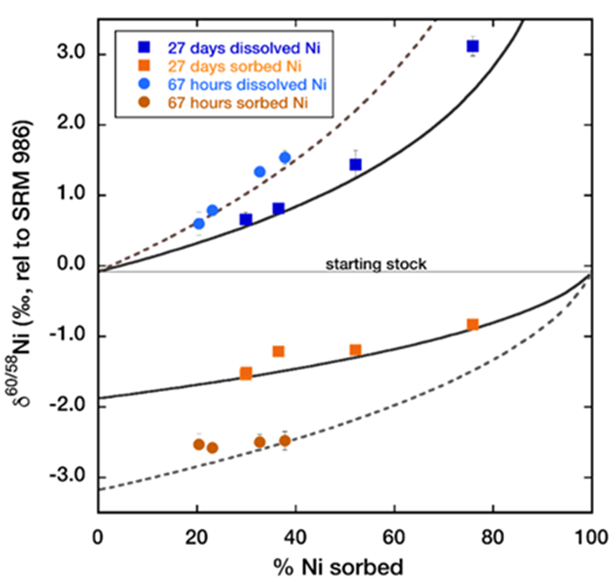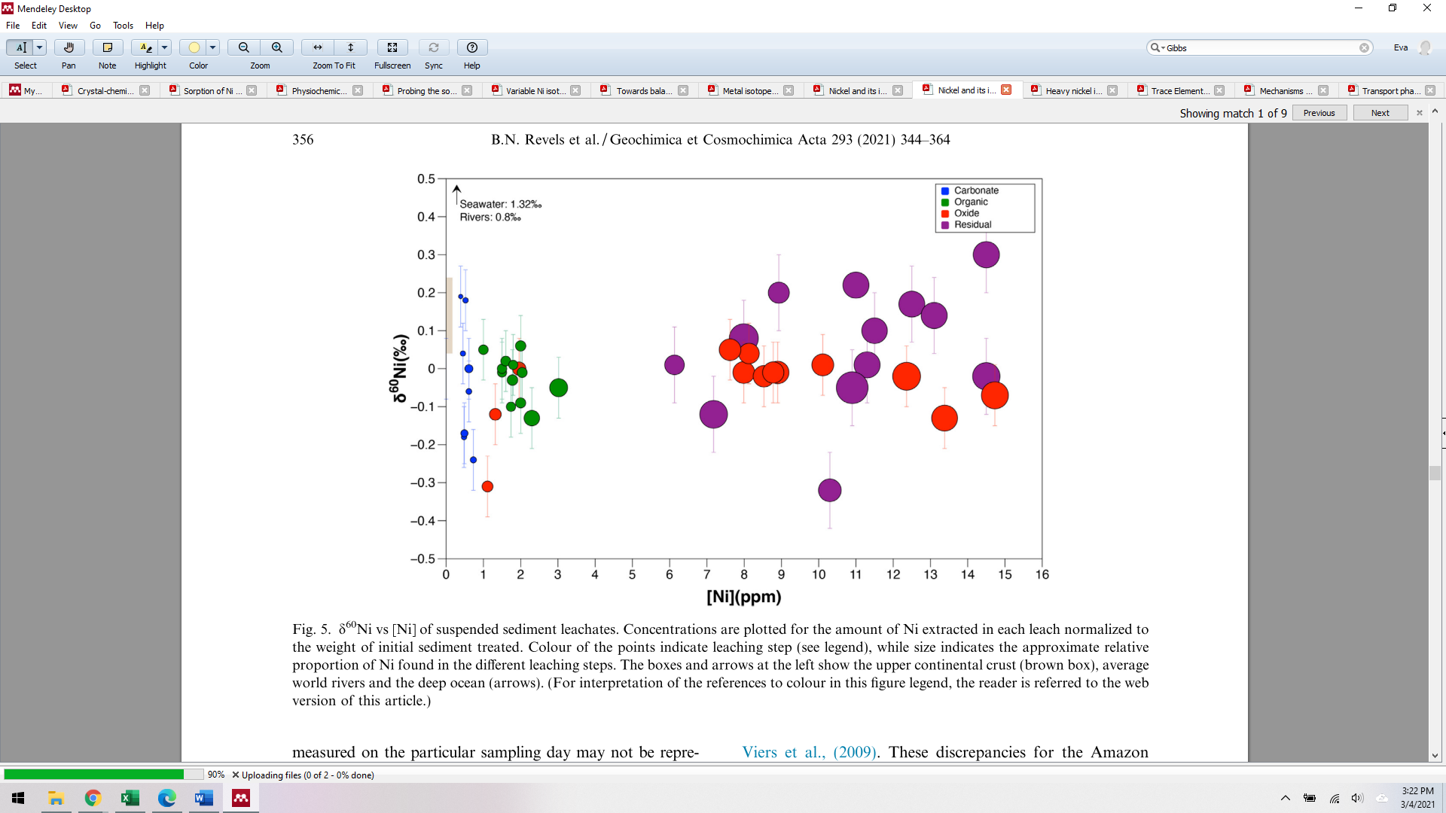Revels 2021

**Figure 1:** Comparison of 67-hour and 27-day birnessite Ni-sorption experiments. The solid black and dotted black lines are best-fit Rayleigh curves for the 27-day and 67-hour experiments respectively13.

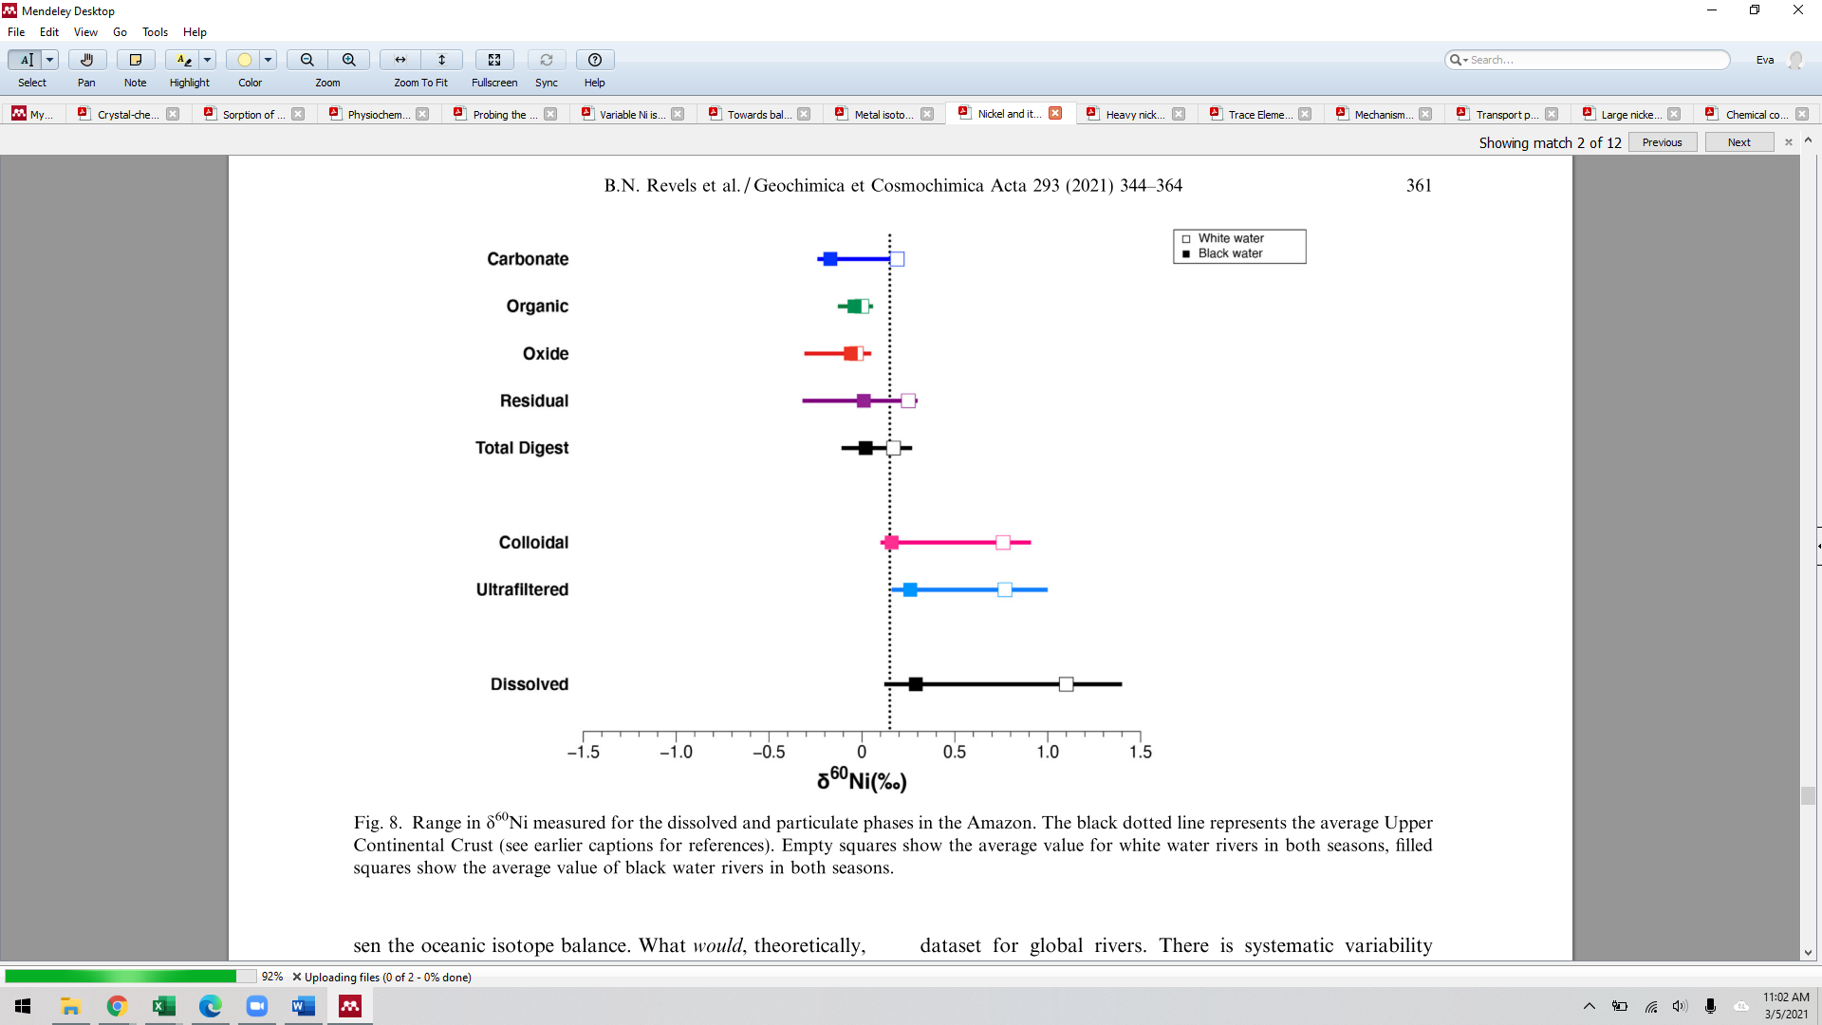revels 2021

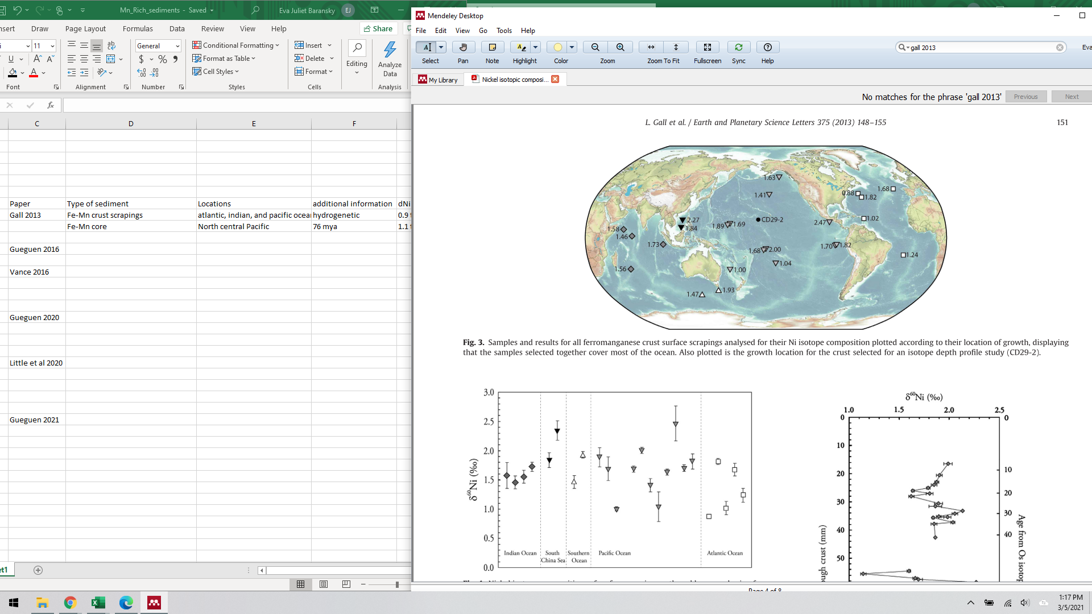Gall 2013 (locations of samples)

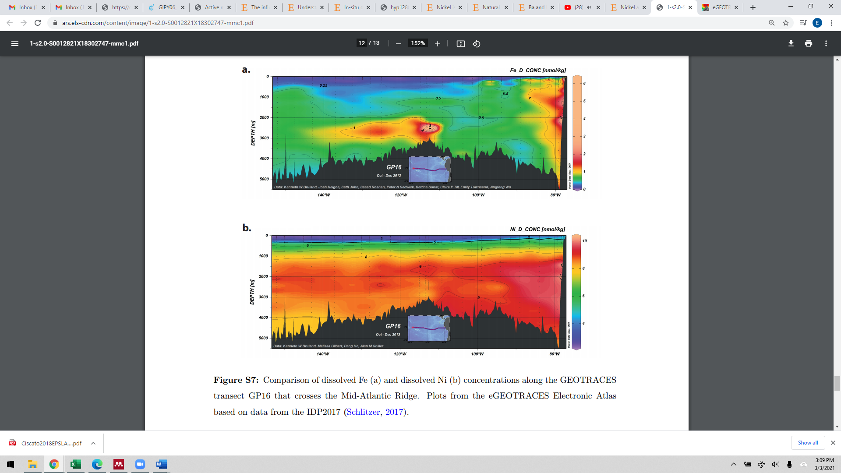

Ciscato 2018 supplemental information, Plots from the eGEOTRACES Electronic Atlas based on data from the IDP2017 (Schlitzer, 2017)

Gueguen 2021 (adapted)

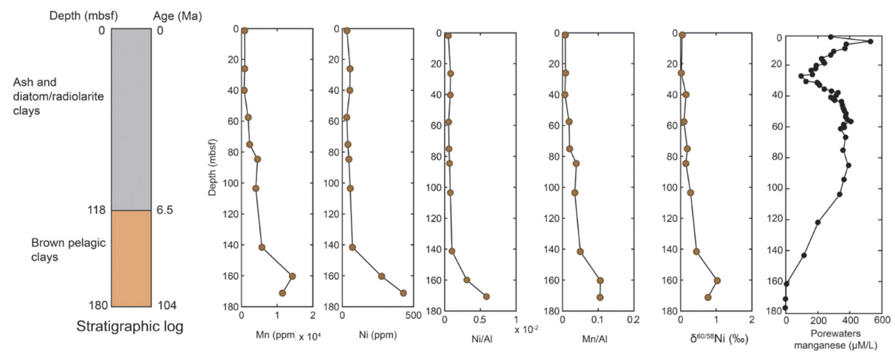

Little 2020

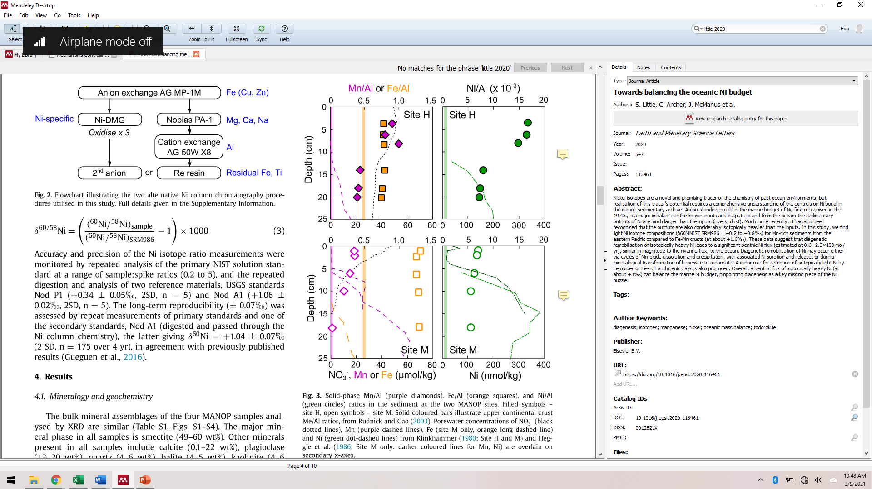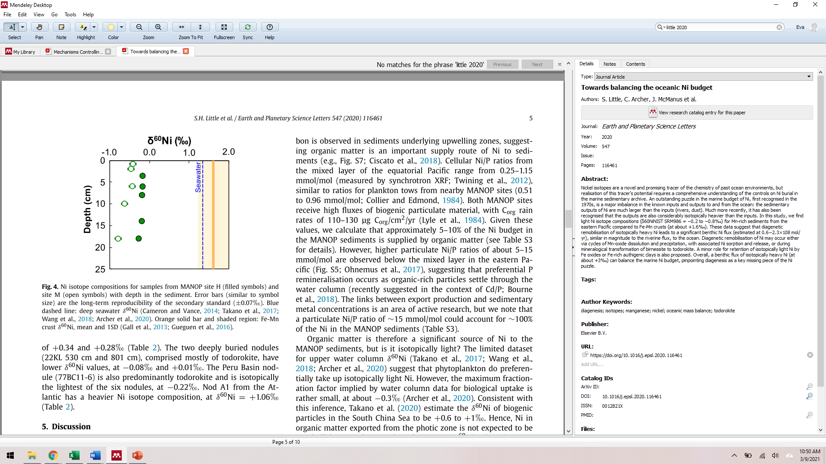little f